The Zeeman Effect:

The Zeeman effect refers to the splitting of electronic energy levels in an atom due to the application of an external magnetic field. Essentially the magnetic properties of the electron in the given electronic state couple with the external magnetic field (simply two magnets interacting). The electrons magnetic properties are also coupled with its angular momentum, so in many ways it resembles a spinning top in a gravitational field. However, there are quantum behaviors.

Ultimately the magnetic splitting of the energy levels can be observed via the atomic emission spectra (this is what we are doing). The degree of the energy level splitting relates to the details of the particular atomic transition we are looking at, with much of the fundamental constants being swept into a single constant called the Bohr Magneton, μ_{B.} We will be determining the Bohr magneton.

I will refer to the Pasco manual (I am referencing now—but is intended to copy parts for educational use), but I will streamline the procedure and note that we are only doing the one experiment for 90º polarization. The instrument alignment and conditions are touchy, and I don’t want them “touched” once aligned.

Theory:

Part 1) Zeeman Effect
We are looking at the 546.1nm transition in mercury (we have a mercury lamp that fits in a sizable magnet).

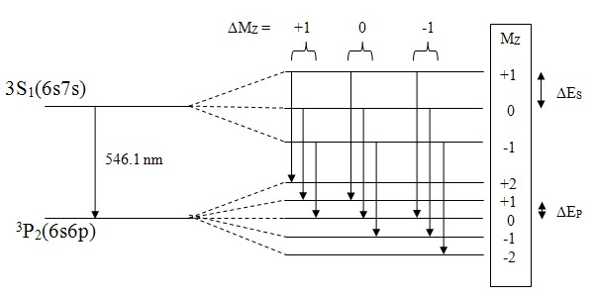
Figure 1: Energy Levels for 546.1 nm Hg Spectral Line

When in a magnetic field the energy levels split into a complicated structure as shown on the right of Fig. 1. Selection rules allow for transitions between stats with different magnetic sublevels (different z components of electronic spin) such that ΔM_{z}= ±1, 0.
(pasco uses Cap M, so as not to confuse with mass m). The ΔM_{z}= 0 produce lines polarized parallel to the B field, and the others can be eliminated with a polarizer. This makes the pattern we will see for allowed transitions much simpler!

In general, when we view the interference pattern, for each fringe labeled with some number such as “n-k”, we will observe the fringe (ring) split into three parts when an external B field is applied. An outer ring that has a slightly shorter wavelength and inner ring slightly longer, and the center ring has the same wavelength as the original zero B field. The outer ring is the M_{z}=+1 to M_{z}=+1 transition (upper to lower state), center is 0 to 0, and inner is -1 to -1. Note again, we have selected all transitions to have ΔM_{z}= 0 by choice of viewing geometry and polarizer.

In our experiment, the interference pattern allows us to ultimately determine the difference in wavelength for the different rings (outer and inner) and to get the Bohr magneton from that. I refer to Pasco eq. 7.
h(c/λ₊ - c/λ₋) = hc(λ₋ - λ₊)/(λ₋)( λ₊) = hcΔλ/λ² = Bμ_{B}

Δλ = Bμ_{B} λ²/hc Eq. 7

where (λ₋)( λ₊) = λ² to extremely good approximation.
You can see the Pasco derivation of equation 7, but we have now converted the Zeeman effect into an expected result for the wavelength separation and related that to the goal of finding the Bohr Magneton.

We will measure Δλ (you will never see that as a number—we will put that in terms of interference pattern geometry), B field, and then you can determine the Bohr Magneton.

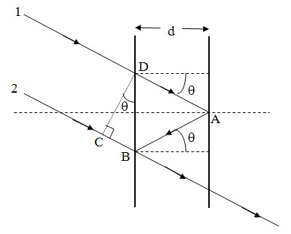
Figure 2: Fabry-Perot Geometry

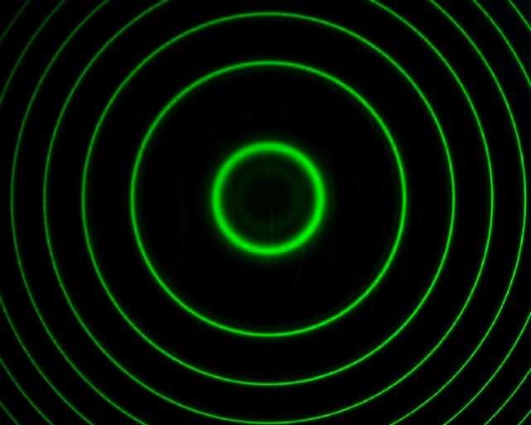
Figure 3: B=0 Pattern

Theory
Part II) The Interference Pattern

The Fabry Perot etalon is a fixed gap set of two partially reflecting mirrors set at a spacing of d=1.995mm. It is possible to do minor adjustments (DON’T TOUCH IT). But this and all components have been aligned well for you. The geometry is very similar to the Michelson where a mirror and image of a mirror were used. Here, we have two actual parallel mirrors and high reflectivity R, which produces sharp fringes in comparison to the Michelson. The geometry is the same for the location of fringe maxima (the bright rings).

The Pasco person really fumbled equation 8, I will simplify. This equation states that the path difference on the left must equal a whole number of wavelengths to be at a fringe that we shall call the k^{th} fringe (0, 1, 2, 3 etc) or ring from the center of the pattern.

2d cos θ_{k}=(n-k)λ

We then make a small angle approximation for cosine to yield

2d(1 – θ_{k}²/2) = (n - k)λ where k = 0, 1, 2, 3… Eq. 9

The number n, is the true fringe number at the center of the pattern like---n=2d/λ=7,306.35 (if you must know), but we don’t need this and it folds out of what follows. Only our counting numbers k will ultimately matter.

Unfortunately we don’t have easy measurements on the exact geometry, nor do we have calibrated number on the fringe radius measurements. However, we can remove all this by making relative ring radius measurements and then all the geometry folds away. The reason for this is that IF I COULD CHANGE THE WAVELENGTH, I would see the ring move from a current position to the next ring after some change. When a wavelength exists in my pattern that is say 1/10th of the way between rings—then we have a change from the known wavelength that is one tenth of the noted change.

Ultimately the relative changes in R for, +, -, and 0 (k_{+,} k₋, and k₀) rings gives us everything we need. We will measure relative R’s---and that will eliminate need for angles in Eq. 9

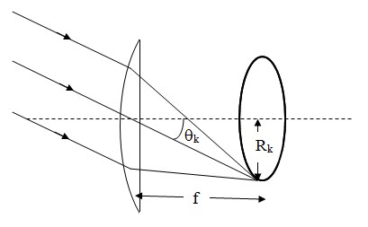
Figure 4: Camera Geometry

For small angles and referring to Fig. 4, we have

2d(1 – R_{k}²/2f²) = (n - k)λ where k = 0, 1, 2, 3… Eq. 10

And

2d(1 – R₀²/2f²) = nλ Eq. 11

What we know and don’t know. We know d, k, and we measure all R’s (uncalibrated), remember that the angle R/f is not known. The R’s are uncalibrated, so we must find the same scaled triangle “f” that goes with the R’s.

Subtract equation 11 from 10 to yield

d/ (f²λ) = k/(R_{k}² – R₀²) Eq. 12

Rearrange as

R_{k}²= kλf²/d+R_{o}² Rearranged Eq. 12

You can now take your data for R² (fixed intercept is measured and known), vs k, fit for a slope and determine “f”. This is an uncalibrated relative f, but this uncalibrated f, along with measured R’s, produce the correct angles. We have f, so the data you have for R’s can be used to solve for the Bohr Magneton, which should be constant.

(d/f²)(R_{k+}² – R_{k-}²) = (B μ_{B} λ2d/(hc)) Eq. 13

Solve for the Bohr Magneton, take each of your ring data sets for + and -, calculate a result and take an average.

Procedures and Tasks:

Your task, should you choose to accept it (no choice) is to determine the Bohr Magneton.

The optical alignment is completed. Don’t touch anything along the optical rail. You will be using the computer with Capstone software to take interference pattern images, and will be turning the magnet and lamp (one button) on/off. Leave the magnet current at zero until recording your video. When recording you will turn the magnet current to max, stop recording, and turn magnet and lamp off.

- The optical setup for steps 1-6 in Pasco manual are completed. This includes a lens to image the mercury lamp onto the Fabry-Perot, a polarizer to rid us of unwanted spectral lines, positioning each element including the Fabry-Perot and camera.
- Steps 8 through 13 are also completed.
- Push the button “on” for the mercury lamp and magnet power supply, making sure the current for the magnet is at zero.
- You must log onto computer with your account and open the Capstone software.
- When the program loads, wait and answer no to the update
- At the right side of the screen double click the video analysis button and select CAPTURE VIDEO ONLY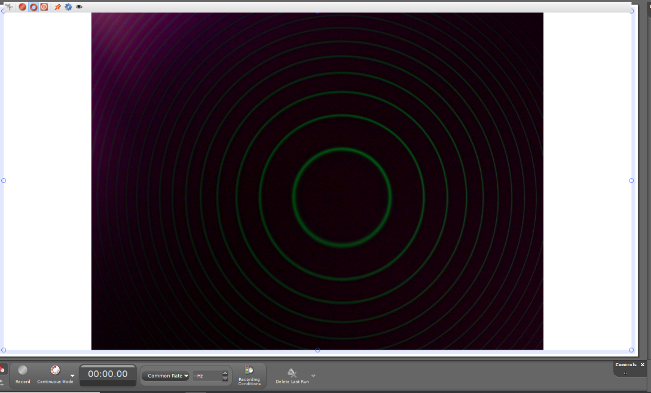
- The software should bring up a good clean image of green rings. The program runs kludgy so trust me, hit the red button at the upper left once, then a few seconds later again. This makes a recording you will ditch—but enables the modes at the bottom of the screen. The red ring (top left allows the monitor to be restored).
- Sometimes the monitoring of camera got stuck—I needed to restart program.
- After you do the false recording, you can enter preview mode at the bottom left, and delete the last run. NOW THE RECORD BUTTON AT THE LOWER LEFT, AND TIMER ARE ENABLED.
- Some notes here. I was able to get much brighter rings by adjusting the camera settings and taking data in a very dark room. A right click on the white background allows you to adjust the display and movie settings. I had exposure at one notch under maximum time, and other properties as indicated below. “Many Bothans……”…..I needed to get used to the software and lighting to adjust this several times (restarting program –kludgy) to get the brightness and contrast adjusted. You may need to play with this. View the pattern at both zero field and max B (leaving current on for short time---no more than a minute while you adjust).
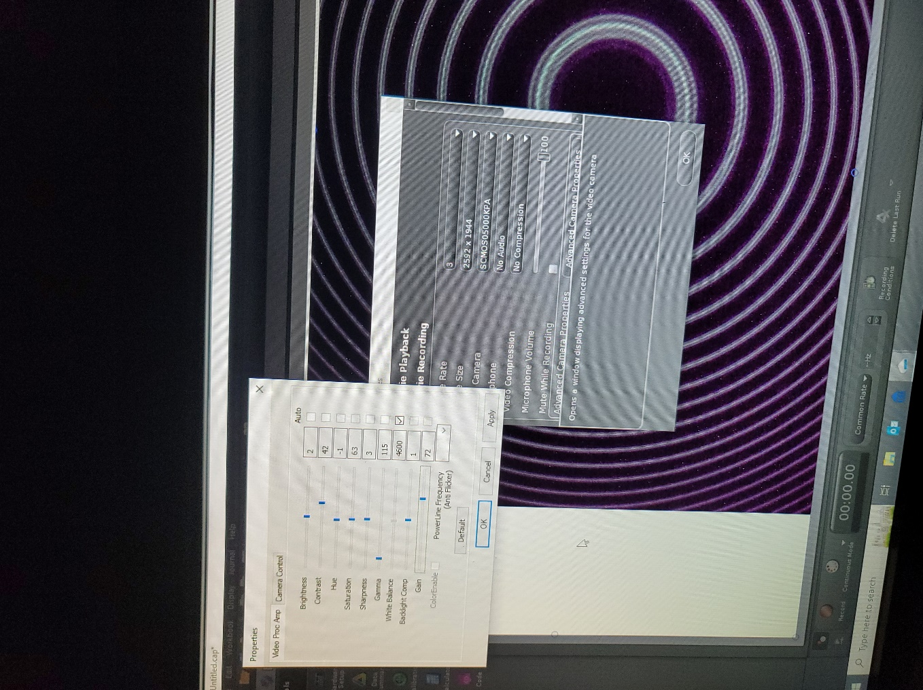

- Room lights off, lamp light not entering camera, camera can tell if there is light off the white back wall, or monitor screen. You must have rings when the magnet is on that look like just above. Turn magnet off.
- Your data consists of recording the video quickly---you will start recording (lower left red button), you will crank the current up all the way (I=~6.09A and the measured B field in the gap is 1.130T (use this—it does not change much here with small current adjustments).
- Your video should take no longer than about 20 seconds to turn up current all the way, and you should now see clear split rings for ring k=0, 1, 2, etc. TURN OFF THE LAMP AND MAGNET.
- Save your capstone file. I believe you can save the movie separately with a right click option on the movie screen.
- Now use the RING MEASURING TOOL. 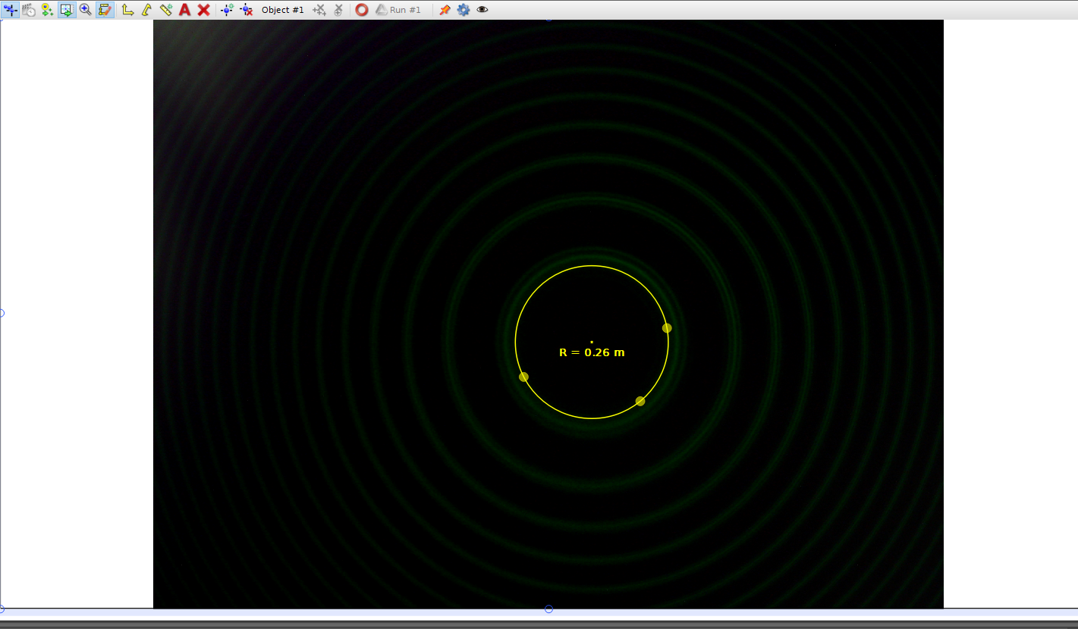
- You may have other tools showing. You can click on them and make them invisible. The ring tool comes up on the little ruler to the left of the “A” in the above picture.
- Your ring tool has a magnifier. Drag each of the three dots to a good ring center for a given k, measure center ring radius, inner radius, outer for several rings (I was easily able to do six rings). THIS IS YOUR DATA.
- I did not and do not use the capstone software to analyze. I write down in a table with ring number, inner, center, outer radii. You will need to also square each, and will need a column with R₊²-R₋² for each ring.

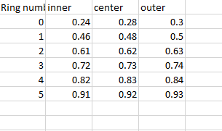

Analysis:

A plot of R_{k}² vs. k, with linear fit going through the measured intercept will determine “f” in some scaled units.

You know the wavelength is 546.1 nm, d=1.995mm and now you will have “f”. You know other constants.

You may now use equation 13 to solve for the Bohr Magneton for each k. Take an average of your values, find the standard deviation in values to report as your uncertainty. I have yielded two results myself. With a slightly different method and improperly aligned 1.05x10⁻²³J/T (slightly high). With better alignment and the method described here, I obtained (9.4±1.3)x10⁻²⁴ J/T

